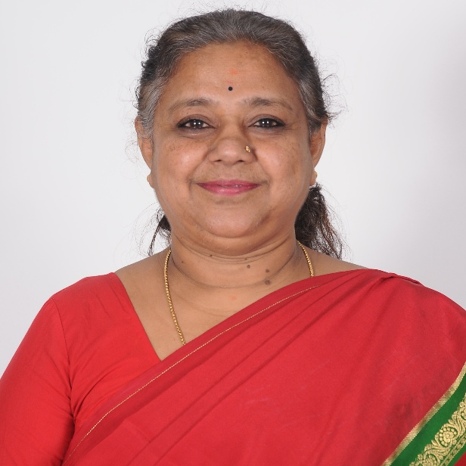
PUSPHA N
M.A., M.Phil., MBA
ACADEMIC DEAN (UG)

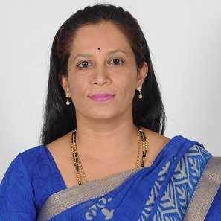
DR. ARCHANA AMBEKAR
MBA, M.Phil., Ph.D.
ACADEMIC DEAN (PG)

